Task 1
Develop a C program that uses the system call open(), read(), write(). And close() to copy the contents of one file to another. Explain how control transitions between user space and kernel space during execution.
Source Code:
#include<stdio.h>
#include<fcntl.h>
#include<unistd.h>
#include<stdlib.h>

Int main(){
Int source, destination;
Char buffer[1024];
size_t bytesRead;
source=open(“source.txt”,O_RDONLY);
if(source < 0) {
perror("Error opening source file");
return 1;
}
destination = open("destination.txt", O_WRONLY | O_CREAT | O_TRUNC, 0644);
if(destination<0){
perror{“Error opening destination file”);
close(source);
return 1;
}
While((bytesRead=read(source,buffer,sizeof(buffer)))>0{
Write(destination,buffer,bytesReead);
}
Close(source);
Close(destination);
Printf(“File copied successfully.\n”);
return 0;
}
Output: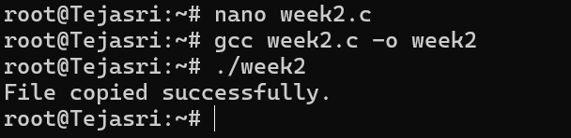
The program starts execution in user space.
The open() system call transfers control from user space to kernel space to open the file.
After opening the file, control returns to user space with a file descriptor.
The read() system call switches to kernel space to read data from the source file.
The kernel copies the data to the user buffer and returns control to the user space.
The write() system call switches to kernel space to write data to the destination file.
After writing the data, control returns to user space.
The close() system call switches to kernel space to close the files and release resources.
The kernel completes the operation and returns to user space, where the program terminates.
Task 2
use the strace utility to trace all system calls generated by the command cat sample.txt. Analyze the sequences or system calls and identify the kernel services involoved
System Call | Purpose | Kernel Service
execve() | Executes the cat program | Process Management
openat() | Opens sample.txt | File System Management
read() | Reads data from the file | File I/O
write() | Displays data on the terminal | Output Management
close() | Closes the file | Resource Management
exit_group() | Terminates the process | Process Termination
Source code(sample.txt):
Hello Linux
Output: 